**Selenium Tutorial 1: Introduction to JAVA**

Today’s topics:

What is Java? History of the JavaJava Components / Java's Tool Suite Java LicenseAdvantages’ of JavaDisadvantages of Java Platforms supported by Java Testing Frameworks and Other Tools used in Java Java Environment Setup jvm, jre ,jdk Class Body explanation Operator in Java and data type Object and class in java

# What is java?

Java is object oriented programing language.

Object oriented language. There are basically four concepts for oops. They are:

1. Inheritance
2. Polymorphism
3. Abstraction
4. Encapsulation.

* **Concurrent** where you can execute many statements instead of sequentially executing it.
* **Class-based** and an **object-oriented** programming language.
* **Independent** programming language that follows the logic of “**Write once, Run anywhere**” i.e. the compiled code can run on all platforms which supports java.

In simple words, it is a computing platform where you can develop applications.

What java can do?

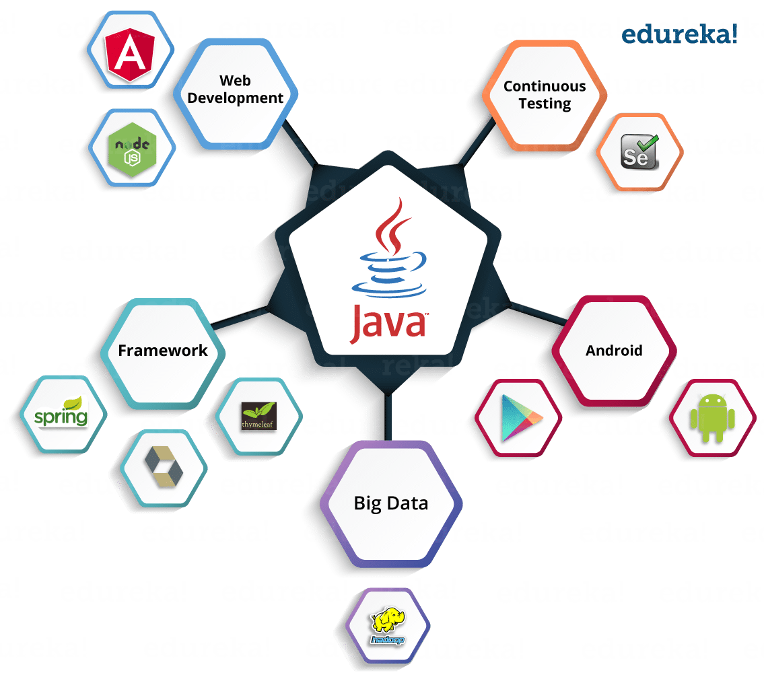

History of java

**Java has three important editions**i) Java Standard Edition / Core Java (Old name J2SE)ii) Java Enterprise Edition / Advanced Java (Old name J2EE)iii) Java Micro Edition (Old name J2ME)Note: Java Standard Edition or Core Java is enough for Automated Testing with Selenium,Java Standard Edition or Core Java-------------------------------------------------

Java Components / Java's Tool Suite

Check out core java syllabus

Java LicenseJava is open source. Java is own by oracle corporation. Anyone can download it for free and use it.

# Advantages’ of Java

.

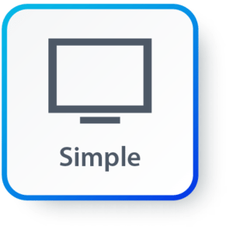**Simple:**Java has made life easier by removing all the complexities such as pointers, operator overloading as you see in C++ or any other programming language.

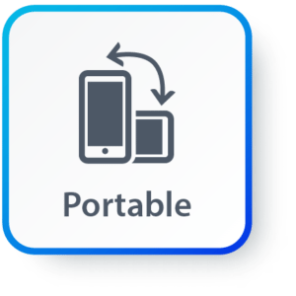

**Portable:**Java is platform independent which means that any application written on one platform can be easily ported to another platform.

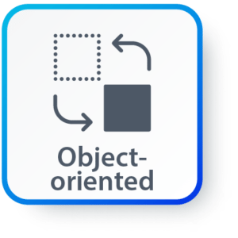**Object-oriented:**Everything is considered to be an “**object**” which possess some state, behavior and all the operations are performed using these objects.

**Secured:**All the code is converted in **bytecode** after compilation, which is not readable by a human. and java does not use an explicit pointer and run the programs inside the sandbox to prevent any activities from untrusted sources. It enables to develop virus-free, tamper-free systems/applications.

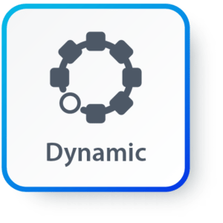**Dynamic:**It has the ability to adapt to an evolving environment which supports dynamic memory allocation due to which memory wastage is reduced and performance of the application is increased.

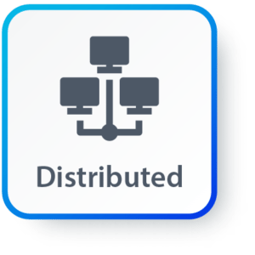**Distributed:**Java provides a feature which helps to create distributed applications. Using Remote Method Invocation (RMI), a program can invoke a method of another program across a network and get the output. You can access files by calling the methods from any machine on the internet.

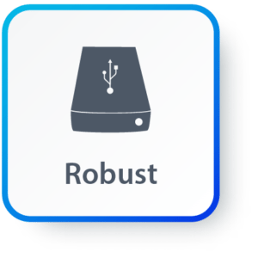**Robust:**Java has a strong memory management system. It helps in eliminating error as it checks the code during compile and runtime.

**High Performance:**Java achieves high performance through the use of bytecode which can be easily translated into native machine code. With the use of JIT (Just-In-Time) compilers, Java enables high performance.

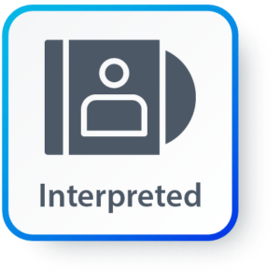**Interpreted:** Java is compiled to bytecodes, which are interpreted by a Java run-time environment.

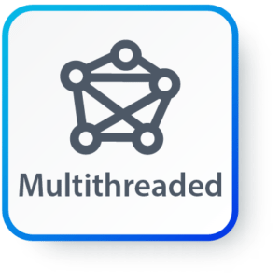**Multithreaded:** Java supports multiple threads of execution (a.k.a., lightweight processes), including a set of synchronization primitives. This makes programming with threads much easier.

## Components in Java

**JVM (Java Virtual Machine)**

It is an abstract machine. It is a specification that provides a run-time environment in which Java bytecode can be executed. It follows three notations:

* **Specification**: It is a document that describes the implementation of the Java virtual machine. It is provided by Sun and other companies.
* **Implementation**: It is a program that meets the requirements of JVM specification.
* **Runtime Instance**: An instance of JVM is created whenever you write a java command on the command prompt and run the class.

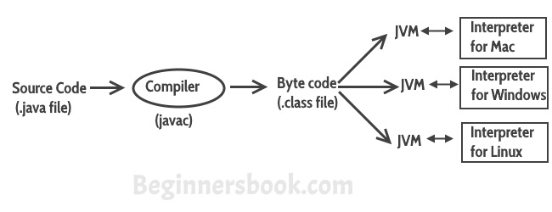

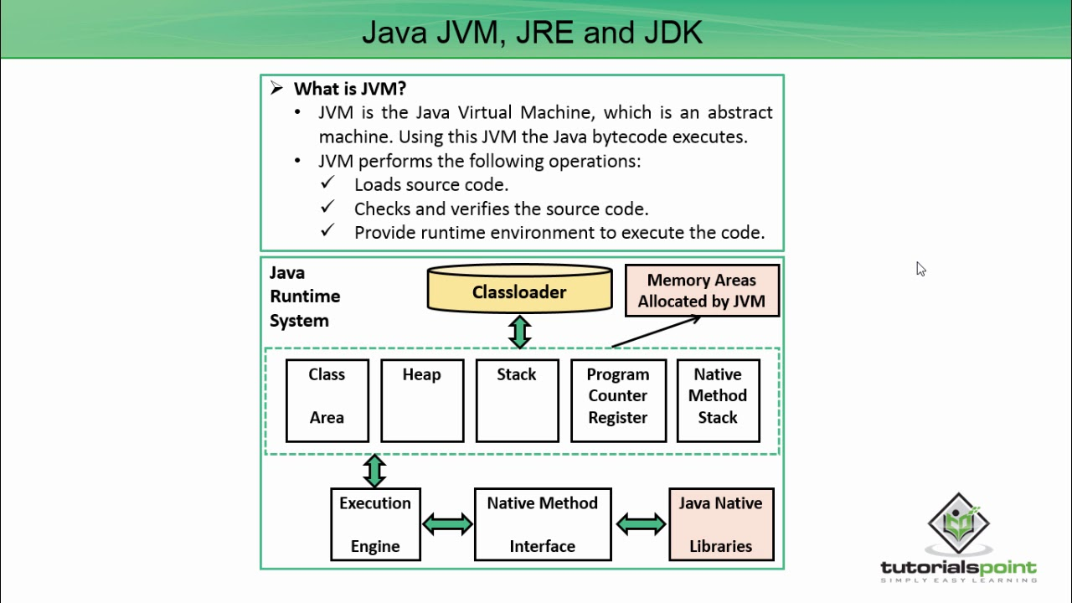

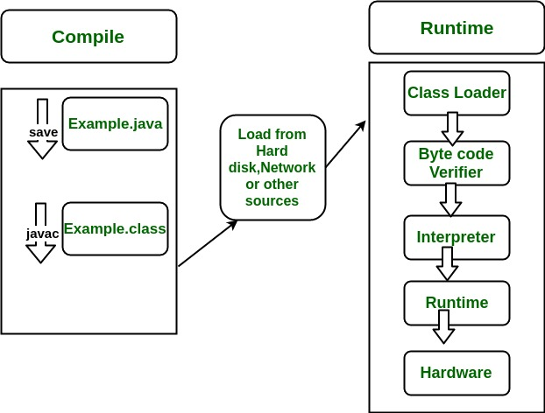

**JRE (Java Runtime Environment)**

JRE refers to a runtime environment in which Java bytecode can be executed. It implements the JVM (Java Virtual Machine) and provides all the class libraries and other support files that JVM uses at runtime. So JRE is a software package that contains what is required to run a Java program. Basically, it’s an implementation of the JVM which physically exists.

**JDK(Java Development Kit)**

It is the tool necessary to:-

* Compile
* Document
* Package Java programs.

The JDK completely includes JRE which contains tools for Java programmers. The Java Development Kit is provided free of charge. Along with JRE, it includes an interpreter/loader, a compiler (javac), an archiver (jar), a documentation generator (Javadoc) and other tools needed in Java development. In short, it contains JRE + development tools.

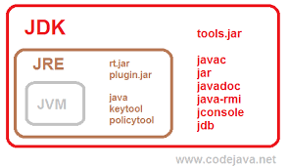

Class Body explanation

**package** variable; = package name

**public** **class** Local { class name= local

String name; =instance variable

Static familyName; =static variable

**public** **static** **void** main(String[] args) { =main method

Local v = **new** Local(); =creating object

v.m1(); = calling method

Local.*m2*(); = calling method

}

**public** **void** m1(){ = instance method

**int** age=20;

System.***out***.println("non static method age" +" "+ age);

}

**static** **void** m2(){ = static method

**final** **int** age=10;

System.***out***.println("this is static method age" +" "+ age); = print message

}

} =end of class

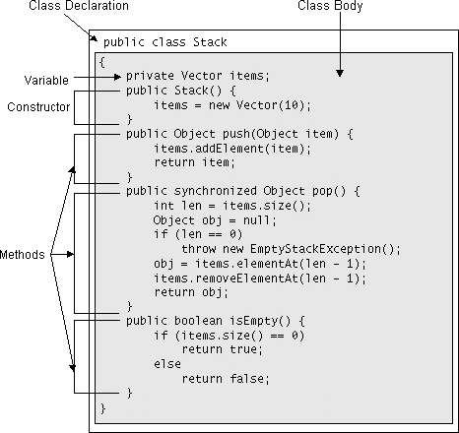

Operator in Java and data type

1) Comments> To make the code readable> To make the code disable from executionNote: Java supports Single line and multiple line comments

----------------------------------------------------------

Note 1: In Computer Programming 80% concepts are common (in every programming language), Syntax may vary from one language to another

Example: Data Types, Variables, Operators, Control Flow (Conditional, Loop and Branching) etc...Note 2: Some features may vary from one language to anotherExample: Functions in C Languages, Methods in Java....

-------------------------------------------------

2) Data Types:

**> A Data type is a classification of the type of data that a variable or object can hold in**

Computer programmingExamples:

Character, Integer,Float, Double.... String Boolean etc...

**Java supports two categories of Data Types,**

i) Primitive Data Types

ii) Non Primitive Data Types / Reference Data Types

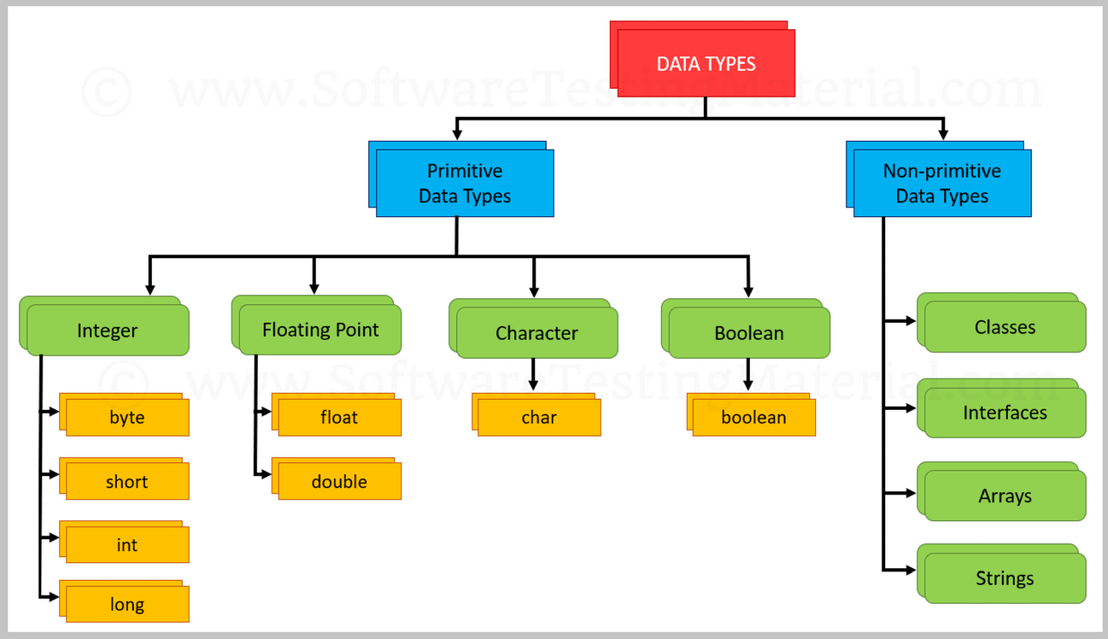

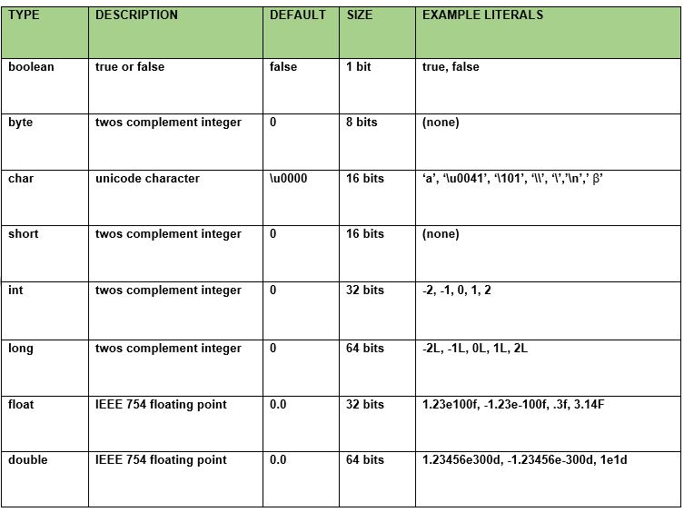

Operator

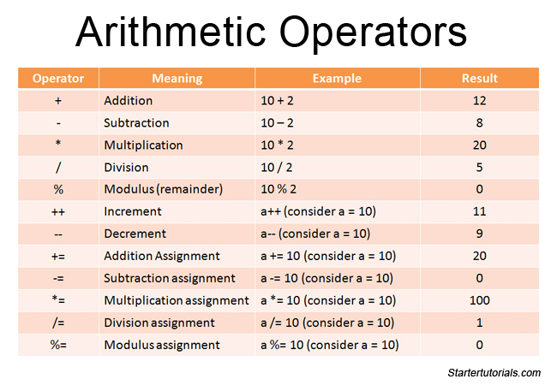

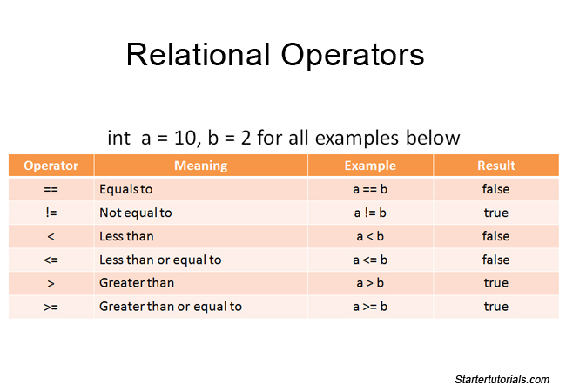

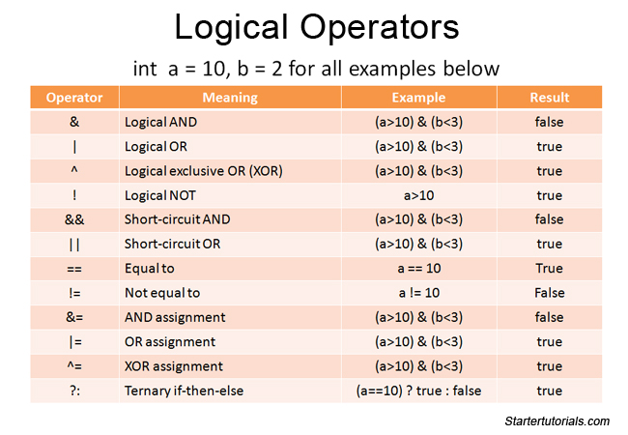

Object and class:

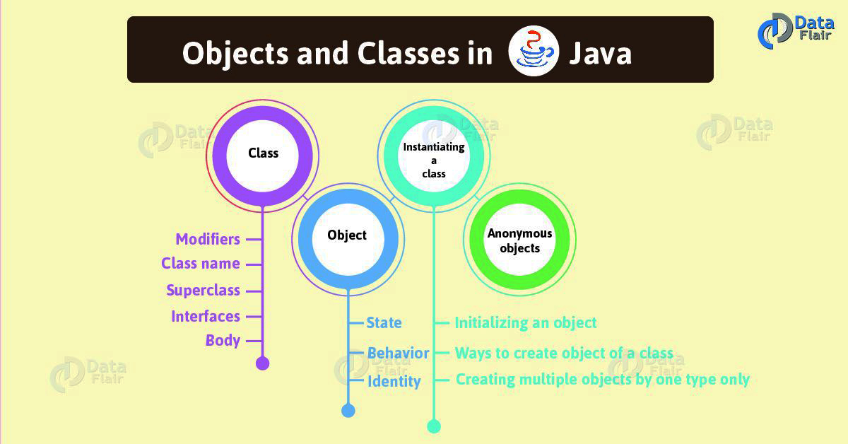

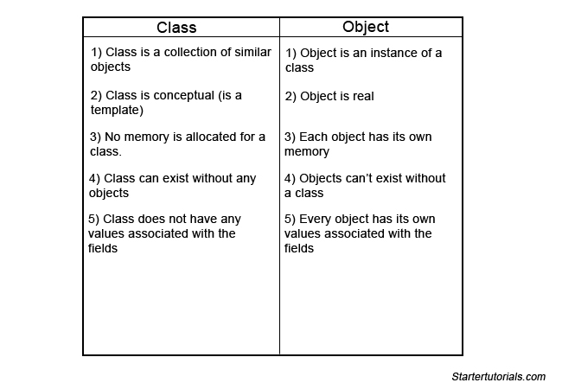

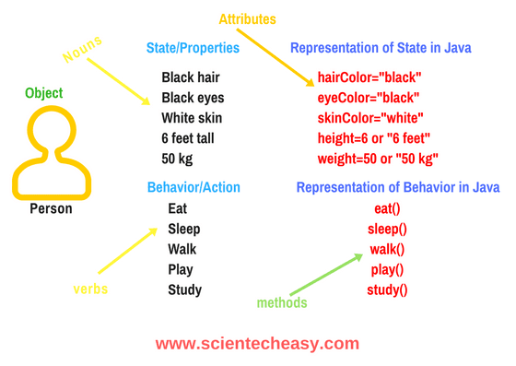

<https://github.com/Faruq2014/java101/tree/master/TEP/src/classAndObject>

***************************************************